

# 

### Semester Two Examination, 2018

### Question/Answer booklet

# MATHEMATICS

**SOLUTIONS**

**METHODS**

**UNITS 3 AND 4**

## Section Two:

## Calculator-assumed

|  |  |  |  |  |  |  |  |  |  |  |
| --- | --- | --- | --- | --- | --- | --- | --- | --- | --- | --- |
| Student number: In figures |  |  |  |  |  |  |  |  |  |  |

In words

Your name

## Time allowed for this section

Reading time before commencing work: ten minutes

Working time: one hundred minutes

## Materials required/recommended for this section

***To be provided by the supervisor***

This Question/Answer booklet

Formula sheet (retained from Section One)

***To be provided by the candidate***

Standard items: pens (blue/black preferred), pencils (including coloured), sharpener,  
correction fluid/tape, eraser, ruler, highlighters

Special items: drawing instruments, templates, notes on two unfolded sheets of A4 paper, and up to three calculators approved for use in this examination

## Important note to candidates

No other items may be taken into the examination room. It is **your** responsibility to ensure that you do not have any unauthorised material. If you have any unauthorised material with you, hand it to the supervisor **before** reading any further.

## Structure of this paper

|  |  |  |  |  |  |
| --- | --- | --- | --- | --- | --- |
| Section | Number of questions available | Number of questions to be answered | Working  time (minutes) | Marks available | Percentage of examination |
| Section One:  Calculator-free | 8 | 8 | 50 | 52 | 35 |
| Section Two:  Calculator-assumed | 13 | 13 | 100 | 98 | 65 |
|  | | |  | **Total** | 100 |

## Instructions to candidates

1. The rules for the conduct of examinations are detailed in the school handbook. Sitting this examination implies that you agree to abide by these rules.

2. Write your answers in this Question/Answer booklet.

3. You must be careful to confine your response to the specific question asked and to follow any instructions that are specified to a particular question.

4. Supplementary pages for the use of planning/continuing your answer to a question  
have been provided at the end of this Question/Answer booklet. If you use these pages to continue an answer, indicate at the original answer where the answer is continued, i.e. give the page number.

5. Show all your working clearly. Your working should be in sufficient detail to allow your answers to be checked readily and for marks to be awarded for reasoning. Incorrect answers given without supporting reasoning cannot be allocated any marks. For any question or part question worth more than two marks, valid working or justification is required to receive full marks. If you repeat any question, ensure that you cancel the answer you do not wish to have marked.

6. It is recommended that you do not use pencil, except in diagrams.

7. The Formula sheet is not to be handed in with your Question/Answer booklet.

Section Two: Calculator-assumed 65% (98 Marks)

This section has**thirteen (****13)** questions. Answer **all** questions. Write your answers in the spaces provided.

Working time: 100 minutes.

Question 9 (6 marks)

The level of Strontium- $90$ in a contaminated soil sample at the start of $1995$ was $0.55$ mg/kg. Strontium- $90$ has a half-life of $28.8$ years and decays continuously such that $S=S_{0}e^{kt}$ where $S$ is the level of Strontium- $90$, $t$ is the time in years since the level was $S_{0}$ and $k$ is a constant.

(a) Assuming no further contamination occurred, determine

(i) the level of Strontium- $90$ in the sample at the start of $2018$. (3 marks)

|  |
| --- |
| **Solution** |
| $$0.5=e^{28.8k} \\ k=-0.02407 \\ S\left(23\right)=0.55e^{-0.02407\left(23\right)}=0.316 \text{mg/kg}$$ |
| **Specific behaviours** |
| ✓ writes equation for $k$ ✓ value of $k$ ✓ value for $S$ that rounds to $0.32$ |

(ii) the rate of change of the level of Strontium- $90$ in the sample at the start of $2018$.

(1 mark)

|  |
| --- |
| **Solution** |
| $$-0.02407×0.316=-0.0076 \text{mg/kg/year}$$ |
| **Specific behaviours** |
| ✓ answer (i) multiplied by $k$ |

(b) Strontium- $90$ decays into Yttrium- $90$. The mass of Yttrium- $90$ decays continuously such that $Y=Y_{0}e^{-0.0101t}$ where $Y$ is the mass of Yttrium- $90$ and $t$ is the time in hours since the level was $Y_{0}$. Determine the time taken for a mass of Yttrium- $90$ to decrease by $90\%$.

(2 marks)

|  |
| --- |
| **Solution** |
| $$e^{-0.0101t}=0.10$$ $$t=228 \text{hours}$$ |
| **Specific behaviours** |
| ✓ writes equation for $t$ ✓ solves for $t$ |

Question 10 (6 marks)

A local council wants to know what proportion of its ratepayers support a recent decision to start charging for parking at its $15$ car parks.

(a) Comment, with reasons, on whether the following sampling methods are likely to introduce bias.

(i) Send a council worker to one randomly selected council car park at $10$ am on a Monday morning and get them to record the responses of the first $20$ drivers who arrive. (2 marks)

|  |
| --- |
| **Solution** |
| Biased, as  - small sample size  - only ask users of car park chosen  - car parkers may not be ratepayers, etc, etc |
| **Specific behaviours** |
| ✓ indicates bias, with reason  ✓ second reason |

(ii) In a council newsletter sent to all ratepayers, include a link to a public page on the council website where users can click a 'yes' or 'no' button to register their support.

(2 marks)

|  |
| --- |
| **Solution** |
| Biased, as  - volunteer sampling  - ratepayers may not have internet access  - web site visitors may not be ratepayers, etc, etc |
| **Specific behaviours** |
| ✓ indicates bias, with reason  ✓ second reason |

|  |
| --- |
| **Examiners note** |
| Interpretation of Confidence Intervals  Suppose that a 95% confidence interval is calculated as [a, b].  A common misconception is to think this means there is a 95% chance that the true population proportion falls between a and b. This is incorrect. Like any population parameter, the population proportion is a constant, not a random variable. It does not change. The probability that a constant falls within any given range is either 0 or 1.  The confidence level describes the uncertainty associated with a sampling method. Suppose we used the same sampling method to select different samples and to compute a different interval estimate for each sample. Some interval estimates would include the true population proportion, and some would not. A 95% confidence level means that we would expect 95% of the interval estimates to include the true population proportion. |

(b) Following the analysis of a large random sample of ratepayers, the council reported that the $95\%$ confidence interval for ratepayer support was from $0.1$ to $0.3$. Mark each of the statements below as **true** or **false**, where false means that the statement does not follow logically from the council's report.

(i) There is a $95\%$ chance that the true proportion of supportive ratepayers lies between $0.1$ and $0.3$. (1 mark)

|  |
| --- |
| **Solution** |
| False. (See notes) |
| **Specific behaviours** |
| ✓ correct response |

(ii) If the random sampling was repeated over and over, then $95\%$ of the time the true proportion of supportive ratepayers will fall between $0.1$ and $0.3$. (1 mark)

|  |
| --- |
| **Solution** |
| False. (See notes) |
| **Specific behaviours** |
| ✓ correct response |

Question 11 (8 marks)

The discrete random variable $X$ has $E\left(X\right)=3.2$ and probability function

$$P\left(X=x\right)=\left\{\begin{matrix}a+bx & x=2, 3, 4 \\ 0, & \text{elsewhere.}\end{matrix}\right.$$

(a) Determine the values of the constants $a$ and $b$. (4 marks)

|  |
| --- |
| **Solution** |
| |  |  |  |  | | --- | --- | --- | --- | |  |  |  |  | |  |  |  |  | |
| **Specific behaviours** |
| ✓ indicates probabilities  ✓ equation for sum of probabilities  ✓ equation for expected value  ✓ values of $a$ and $b$ |

(b) Determine $\operatorname{Var}{(X)}$. (2 marks)

|  |
| --- |
| **Solution** |
| |  |  |  |  | | --- | --- | --- | --- | |  |  |  |  | |  |  |  |  | |
| **Specific behaviours** |
| ✓ indicates probabilities  ✓ correct variance |

(c) A second random variable $Y$ is a linear transformation of $X$ such that $Y=kX+4$, where $k$ is a constant and $E\left(Y\right)=20$. Determine $\operatorname{Var}{(Y)}$. (2 marks)

|  |
| --- |
| **Solution** |
| $$3.2k+4=20⇒k=5$$ $$\operatorname{Var}\left(Y\right)=5^{2}×\frac{47}{75}=\frac{47}{3}=15.\overline{6}$$ |
| **Specific behaviours** |
| ✓ indicates value of $k$ ✓ correct variance |

Question 12 (8 marks)

(a) The graphs of the probability density functions of three normally distributed random variables $W, X$ and $Y$ are shown below.

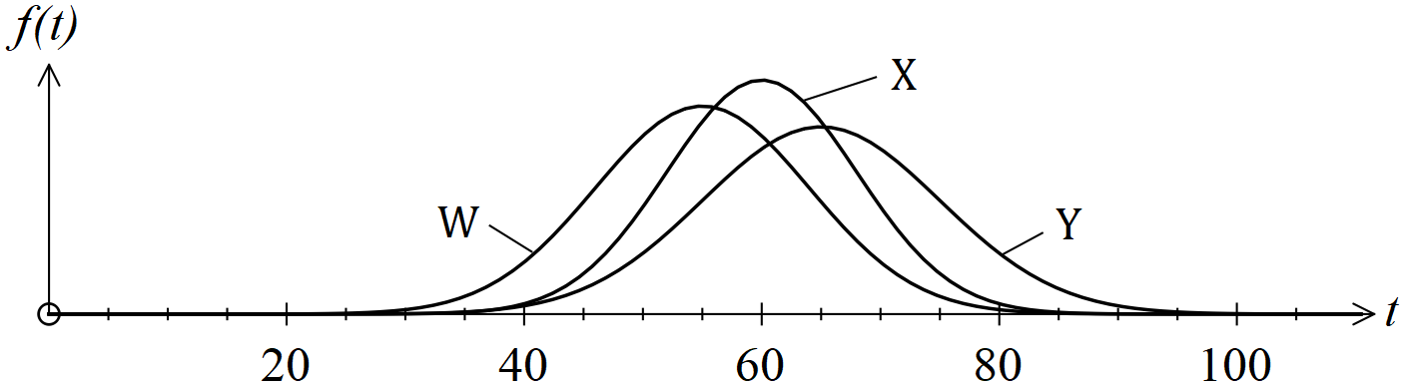

State, with justification, which of the three random variables has

(i) the largest mean? (1 mark)

|  |
| --- |
| **Solution** |
| $Y$- maximum furthest to right |
| **Specific behaviours** |
| ✓ correct variable |

(ii) the smallest standard deviation? (1 mark)

|  |
| --- |
| **Solution** |
| $X$- highest $f_{max}$, so least spread. |
| **Specific behaviours** |
| ✓ correct variable |

(b) Empty bottles are filled with $A$ mL of water, where $A$ is a normally distributed random variable with mean of $380$ mL and standard deviation of $4.5$ mL.

(i) Determine the probability that a bottle is filled with less than $373$ mL. (1 mark)

|  |
| --- |
| **Solution** |
| $$P\left(X<373\right)=0.0599$$ |
| **Specific behaviours** |
| ✓ correct probability |

(ii) Determine the probability that a bottle is filled with more than $375$ mL, given that it is filled with less than $380$ mL. (2 marks)

|  |
| --- |
| **Solution** |
| $$P\left(375<A<380\right)=0.3667$$ $$p=\frac{0.3667}{0.5}=0.7335$$ |
| **Specific behaviours** |
| ✓ numerator  ✓ correct probability |

(iii) The mean of $A$ is to be increased by $k$ mL so that 99% of all bottles are filled with at least $375$ mL. Determine the value of $k$. (3 marks)

|  |
| --- |
| **Solution** |
| $$\frac{375-\overline{x}}{4.5}=-2.326 \\ \overline{x}=385.47 \\ k=385.47-380=5.47 \text{mL}$$ |
| **Specific behaviours** |
| ✓ equation showing correct z-score  ✓ solves for mean  ✓ correct value of $k$ |

Question 13 (8 marks)

$225$ out of a random sample of $1 174$ people in a city had visited a doctor in the last year.

(a) If there were $36 000$ people living in the city, estimate the actual number of these who had visited a doctor in the last year. (2 marks)

|  |
| --- |
| **Solution** |
| $$225÷1174=0.19165$$ $$0.19165×36000≈6 900 \text{people}$$ |
| **Specific behaviours** |
| ✓ indicates proportion  ✓ estimate, to nearest 100 |

(b) Determine the approximate margin of error for a $99\%$ confidence interval for the proportion of people who had visited a doctor in the last year. (2 marks)

|  |
| --- |
| **Solution** |
| $$\text{sd}=\sqrt{\frac{0.19165\left(1-0.19165\right)}{1174}}=0.011487$$ $$E=0.011487×2.576=0.0296$$ |
| **Specific behaviours** |
| ✓ indicates standard deviation  ✓ correct margin of error |

(c) Determine an approximate $99\%$ confidence interval for the true proportion of people who had visited a doctor in the last year. (2 marks)

|  |
| --- |
| **Solution** |
| $$0.19165±0.0296$$ $$\left[0.1621, 0.2212\right]$$ |
| **Specific behaviours** |
| ✓ indicates $\hat{p}±E$ ✓ correct interval |

(d) In order to confirm the sample proportion obtained from the random sample, another sample is to be taken. Estimate, to the nearest $10$ people, the sample size required to obtain an approximate margin of error for a $99\%$ confidence interval that is close to $0.055$.

(2 marks)

|  |
| --- |
| **Solution** |
| $$n=\frac{{2.576}^{2}\left(0.19165\right)\left(1-0.19165\right)}{{0.055}^{2}}$$ $$n≈340$$ |
| **Specific behaviours** |
| ✓ indicates correct method  ✓ correct size |

Question 14 (7 marks)

The table below shows the sign of the polynomial $f(x)$ and some of its derivatives at various values of $x$. There are no other zeroes of $f\left(x\right), f'(x)$ or $f''(x)$ apart from those shown in the table.

|  |  |  |  |  |  |  |  |
| --- | --- | --- | --- | --- | --- | --- | --- |
| $$x$$ | $$-2$$ | $$-1$$ | $$0$$ | $$1$$ | $$2$$ | $$3$$ | $$4$$ |
| $$f(x)$$ | $$+$$ | $$0$$ | $$-$$ | $$-$$ | $$-$$ | $$0$$ | $$+$$ |
| $$f'(x)$$ | $$-$$ | $$-$$ | $$0$$ | $$+$$ | $$+$$ | $$0$$ | $$+$$ |
| $$f''(x)$$ | $$+$$ | $$+$$ | $$+$$ | $$0$$ | $$-$$ | $$0$$ | $$+$$ |

(a) For what value(s) of $x$ is the graph of the function concave up? (1 mark)

|  |
| --- |
| **Solution** |
| $$x<1 \text{and }x>3$$ |
| **Specific behaviours** |
| ✓ correct inequalities and domain |

(b) At what location does the graph of $f$ have a turning point? Explain your answer. (2 marks)

|  |
| --- |
| **Solution** |
| At $x=0$.  The gradient is zero and $f$ is concave up on either side. |
| **Specific behaviours** |
| ✓ location  ✓ explanation |

(c) Sketch a possible graph of $y=f(x)$ on the axes below. (4 marks)

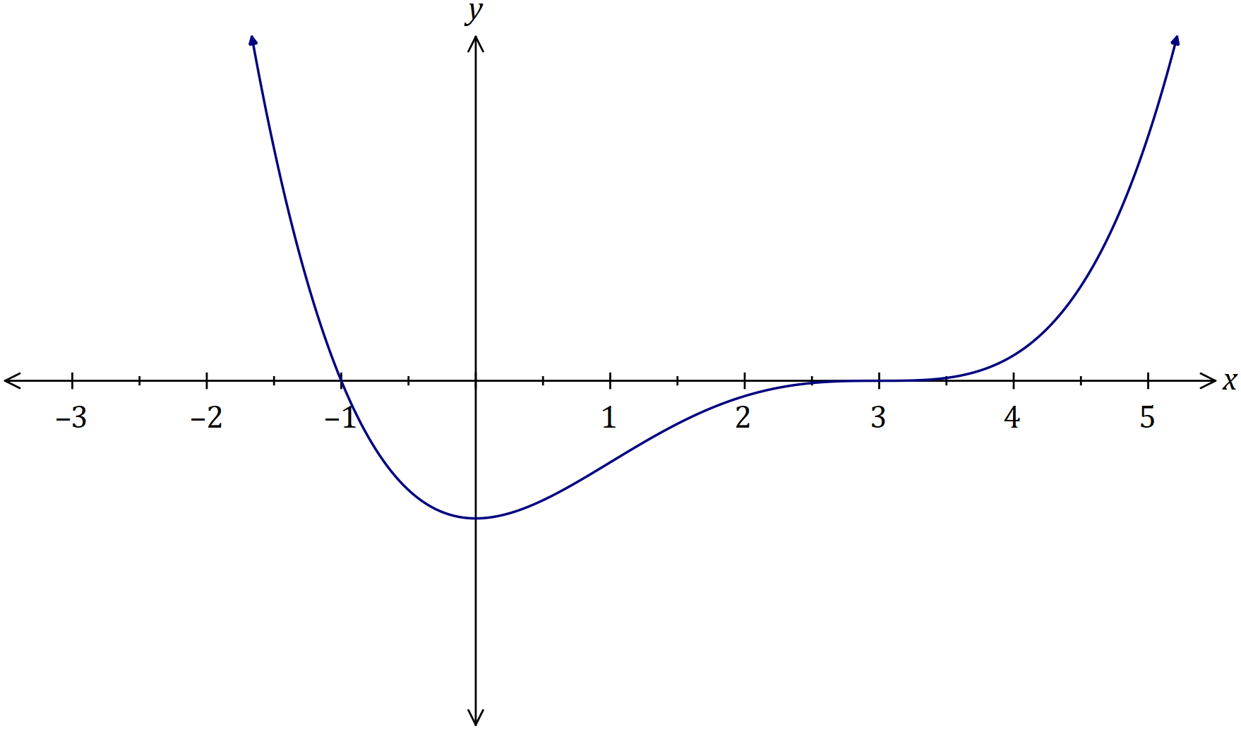

|  |
| --- |
| **Solution** |
| See graph |
| **Specific behaviours** |
| ✓ correct location of roots  ✓ correct location of stationary points  ✓ point of inflection at $x=1$ ✓ concave up everywhere except $1<x<3$ |

Question 15 (10 marks)

Every day a scientific researcher randomly catches $8$ fish from an inland lake containing a large number of fish, $63\%$ of which are thought to be trout.

(a) The random variable $X$ is the number of trout in the daily catch.

(i) Describe the distribution of $X$. (2 marks)

|  |
| --- |
| **Solution** |
| $$X\sim B\left(8, 0.63\right)$$ |
| **Specific behaviours** |
| ✓ indicates binomial  ✓ indicates parameters |

(ii) Over a period of $14$ days, how many times would you expect the daily catch to contain more trout than fish of other species? (2 marks)

|  |
| --- |
| **Solution** |
| $$P\left(X≥5\right)=0.6626$$ $$n=0.6626×14≈9 \text{days}$$ |
| **Specific behaviours** |
| ✓ indicates probability  ✓ correct number of days |

(iii) Determine the probability that a total of $15$ trout are caught over two consecutive days. (2 marks)

|  |  |
| --- | --- |
| **Solution** | |
| $$p=P\left(X=7\right)×P\left(X=8\right)×2 \\ =0.1166×0.0248×2=0.0058$$ | $$Y\sim B(16, 0.63)$$ $$P\left(Y=15\right)=0.0058$$ |
| **Specific behaviours** | |
| ✓ indicates method  ✓ correct probability | |

(b) The researcher suspected that the proportion of trout was lower than thought but more than 50%.

(i) Calculate an approximate $90\%$ confidence interval for the proportion of trout in the lake given that over a $10$-day period, a total of $48$ trout were caught. (2 marks)

|  |
| --- |
| **Solution** |
| $$x=48, n=80, p=0.6$$ $$\text{CI}: \left[0.51, 0.69\right]$$ |
| **Specific behaviours** |
| ✓ indicates $x$ and $n$ ✓ states interval |

(ii) Use the confidence interval to comment on the researcher's suspicion. (2 marks)

|  |
| --- |
| **Solution** |
| No evidence that proportion is lower, as 63% is within the CI, but there is evidence that proportion is more than 50%, as 50% is below the lower bound of CI. |
| **Specific behaviours** |
| ✓ comment on lower than 63%  ✓ comment on more than 50% |

Question 16 (7 marks)

At time $t=0$, a small body $P$ is at the origin $O$ and is moving with a velocity of ms-1. The acceleration of $P$ for $t≥0$ is given by

$$a=\frac{-3}{\sqrt{t+4}} {\text{ms}}^{-2}.$$

(a) Determine the velocity of $P$ when $t=5$. (4 marks)

|  |  |
| --- | --- |
| **Solution** | |
| $$v=\int{a}dt \\ =-6\sqrt{t+4}+c$$ $$c=18+6\sqrt{4}=30$$ $$v=30-6\sqrt{t+4}$$ $$v\left(5\right)=30-6\sqrt{9}=12 {\text{ms}}^{-1}$$ | $$v\left(5\right)=18+\int_{0}^{5}{\left(\frac{-3}{\sqrt{t+4}}\right)}dt$$ $$=18-12=6$$*NB Using net change is quicker in (a), but since an expression for $v(t)$ is needed in (b) best to determine it here.* |
| **Specific behaviours** | |
| ✓ indicates $v$ is integral of $a$ ✓ correct integral  ✓ evaluates $c$ ✓ correct velocity | |

(b) Determine the distance of $P$ from $O$ at the instant $P$ is stationary. (3 marks)

|  |
| --- |
| **Solution** |
| $$v=0⇒30-6\sqrt{t+4}=0⇒t=21$$ $$OP=\int_{0}^{21}{\left(30-6\sqrt{t+4}\right)}dt \\ =162 \text{m}$$ |
| **Specific behaviours** |
| ✓ determines value of $t$ ✓ writes integral for change in displacement  ✓ correct distance |

Question 17 (8 marks)

A student repeatedly took random samples of size $150$ from a large population in which it was known that $38\%$ of people were classified as overweight. For each sample, the proportion of overweight people was calculated and recorded as the sample proportion.

(a) Use an appropriate binomial distribution to determine the probability that the sample proportion is no more than $0.34$ in a randomly chosen sample. (3 marks)

|  |
| --- |
| **Solution** |
| $$X\sim B\left(150, 0.38\right)$$ $$0.34×150=51$$ $$P\left(X≤51\right)=0.1777$$ |
| **Specific behaviours** |
| ✓ states parameters  ✓ indicates most number of successes  ✓ correct probability |

(b) After recording a large number of sample proportions, the student used them to create a histogram from which the approximate normality of their distribution was evident.

(i) Determine the expected mean and standard deviation of the observed normal distribution. (2 marks)

|  |
| --- |
| **Solution** |
| $$\text{mean}=0.38$$ $$\text{sd}=\sqrt{\frac{0.38\left(1-0.38\right)}{150}}≈0.0396$$ |
| **Specific behaviours** |
| ✓ correct mean  ✓ correct sd |

(ii) Use this normal distribution to determine the probability that the sample proportion is no more than $0.34$ in a randomly chosen sample. (1 mark)

|  |
| --- |
| **Solution** |
| $$P\left(X<0.34\right)=0.1564$$ |
| **Specific behaviours** |
| ✓ correct probability |

(iii) Describe how the parameters calculated in (i) would change if the student took smaller random samples. (2 marks)

|  |
| --- |
| **Solution** |
| Mean would stay the same.  SD would increase. |
| **Specific behaviours** |
| ✓ states no change in mean  ✓ states increase in sd |

Question 18 (11 marks)

The time $T$ to process orders at a warehouse is random variable which can take any value in the interval $0$ to $12$ minutes. The graph of the triangular probability density function of $T$ is shown below.

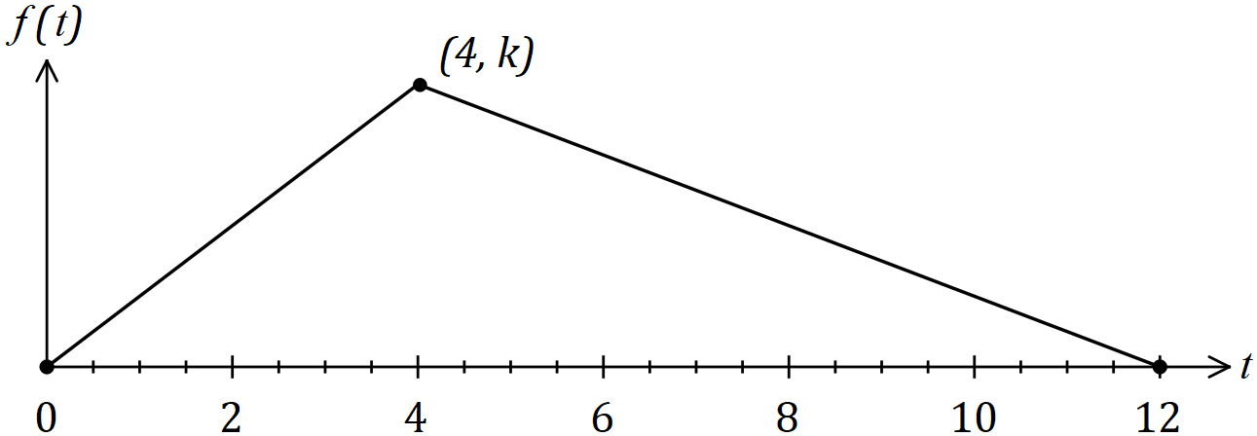

(a) Determine the value of $k$. (1 mark)

|  |
| --- |
| **Solution** |
| $$\frac{1}{2}\left(12\right)\left(k\right)=1⇒k=\frac{1}{6}$$ |
| **Specific behaviours** |
| ✓ correct value |

(b) Determine the probability that the time to process an order takes less than $3$ minutes.

(3 marks)

|  |
| --- |
| **Solution** |
| $$f\left(t\right)=\frac{t}{24}, 0≤t≤4$$ $$P\left(T<3\right)=\int_{0}^{3}{\left(\frac{t}{24}\right)}dt=\frac{3}{16}=0.1875$$ |
| **Specific behaviours** |
| ✓ indicates $f(t)$ for interval  ✓ indicates integral  ✓ correct probability |

(c) Determine the mean time to process an order in minutes and seconds. (4 marks)

|  |
| --- |
| **Solution** |
| $$g\left(t\right)=\frac{-1}{48}\left(t-12\right), 4<t≤12$$ $$E\left(T\right)=\int_{0}^{4}{t\left(\frac{t}{24}\right)}dt+\int_{4}^{12}{t\left(\frac{-1}{48}(t-12)\right)}dt \\ =\frac{16}{3}=5\frac{1}{3}$$ $$\text{Mean is} 5 \text{min} 20 \text{sec}.$$ |
| **Specific behaviours** |
| ✓ indicates $g(t)$ for second interval  ✓ indicates both integrals  ✓ evaluates mean  ✓ writes mean as required |

The variance of $T$ is $6$ minutes $13$ seconds.

(d) Two new procedures will affect the processing time of an order. The first will decrease the time by $15\%$ and the second will then add one-and-a-half minutes. Determine the new mean and standard deviation of the time to process an order. (3 marks)

|  |
| --- |
| **Solution** |
| $$E\left(0.85T+1.5\right)=0.85×5\frac{1}{3}+1.5 \\ =6.03 \text{min} (6 \text{m} 2 \text{s})$$ $$σ_{old}=\sqrt{6\frac{13}{60}}=2.493$$ $$σ_{new}=0.85×2.493 \\ =2.12 \text{min} \left(2 \text{m} 7 \text{s}\right)$$ |
| **Specific behaviours** |
| ✓ new mean  ✓ indicates original sd  ✓ new sd |

Question 19 (8 marks)

(a) The graph of $y=f(x)$ is shown together with some values of $f(x)$.

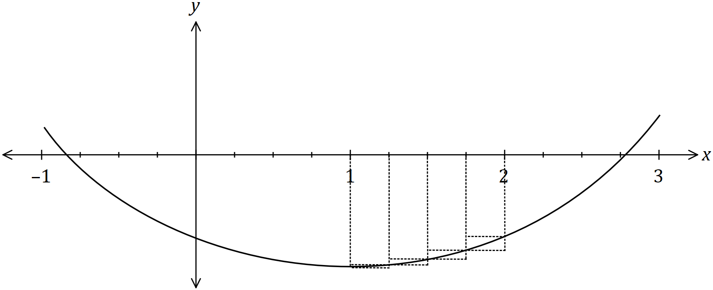

|  |  |  |  |  |  |  |  |
| --- | --- | --- | --- | --- | --- | --- | --- |
| $$x$$ | $$0.75$$ | $$1$$ | $$1.25$$ | $$1.5$$ | $$1.75$$ | $$2$$ | $$2.25$$ |
| $$f(x)$$ | $$-9.3$$ | $$-10.2$$ | $$-9.5$$ | $$-8.5$$ | $$-7.2$$ | $$-6.6$$ | $$-5.9$$ |

By considering the areas of the rectangles shown and using values of $f(x)$ from the table, calculate a numerical approximation for $\int_{1}^{2}{\underset{ }{\overset{ }{f(x)}}}dx$. (4 marks)

|  |
| --- |
| **Solution** |
| $$\text{Over estimate}=0.25\left(10.2+9.5+8.5+7.2\right) \\ =8.85$$ $$\text{Under estimate}=0.25\left(9.5+8.5+7.2+6.6\right) \\ =7.95$$ $$\text{Area estimate}=\left(8.85+7.95\right)÷2=8.4$$ $$∴\int_{1}^{2}{f(x)}dx≈-8.4$$ |
| **Specific behaviours** |
| ✓ over estimate of area  ✓ under estimate of area  ✓ averages for best estimate of area  ✓ correct sign for integral |

(b) The graph of $x=2y^{2}-12$ and the line $4y=x+6$ are shown below.

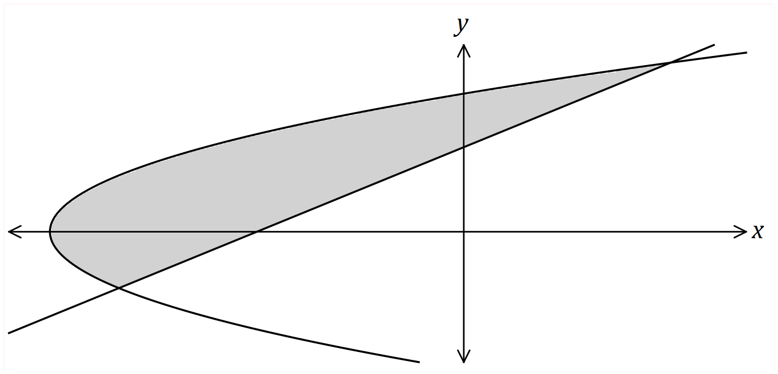

Determine the area bounded by the line and the curve. (4 marks)

|  |
| --- |
| **Solution** |
| Line-curve intersect when $x=-10, 6$ (CAS)  When $y=0$, $x=-12$.  Curve: $y=±\sqrt{0.5x+6}$ Line: $y=0.25x+1.5$ $$A_{1}=\int_{-10}^{6}{\left(\left(\sqrt{0.5x+6}\right)-\left(0.25x+1.5\right)\right)}dx \\ =\frac{56}{3}$$ $$A_{2}=\int_{-12}^{-10}{\left(\left(\sqrt{0.5x+6}\right)-\left(-\sqrt{0.5x+6}\right)\right)}dx \\ =\frac{8}{3}$$ $$A=A_{1}+A_{2} \\ =\frac{64}{3} \text{sq units}$$ |
| **Specific behaviours** |
| ✓ points of intersection  ✓ correct integral $A_{1}$ ✓ correct integral $A_{2}$ ✓ correct area |

|  |
| --- |
| **Alternative Solution** |
| Line and curve intersect  when $y=-1, 3$ (CAS)  Line: $x=4y-6$ $$A=\int_{-1}^{3}{\left(\left(4y-6\right)-(2y^{2}-12)\right)}dy \\ =\frac{64}{3} \text{sq units}$$ |
| **Specific behaviours** |
| ✓ points of intersection  ✓ correct integrand  ✓ correct bounds  ✓ correct area |

Question 20 (5 marks)

The graph of $y=f(x)$ is shown below.

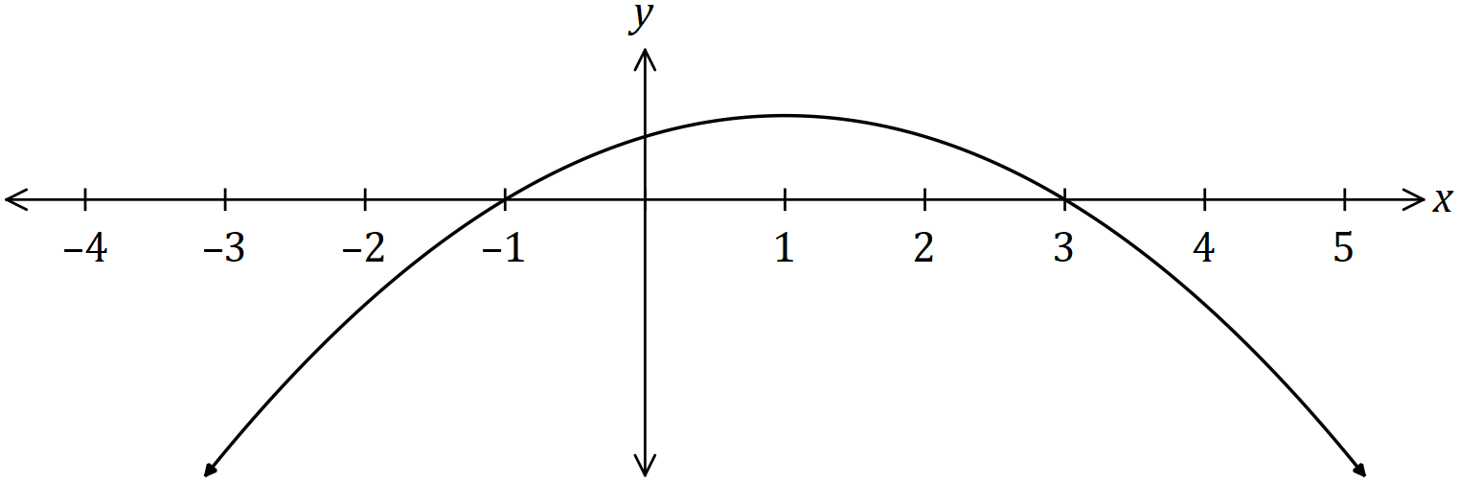

Another function $A$ is defined on the interval $-3≤x≤5$ by

$$A\left(x\right)=\int_{-3}^{x}{f(t)}dt.$$

It is known that $A\left(-1\right)=A\left(5\right)=-9$ and $A\left(3\right)=0$. Sketch the graph of $y=A(x)$ on the axes below, clearly indicating the location of all $x$-intercepts, turning points, points of inflection and other key features.

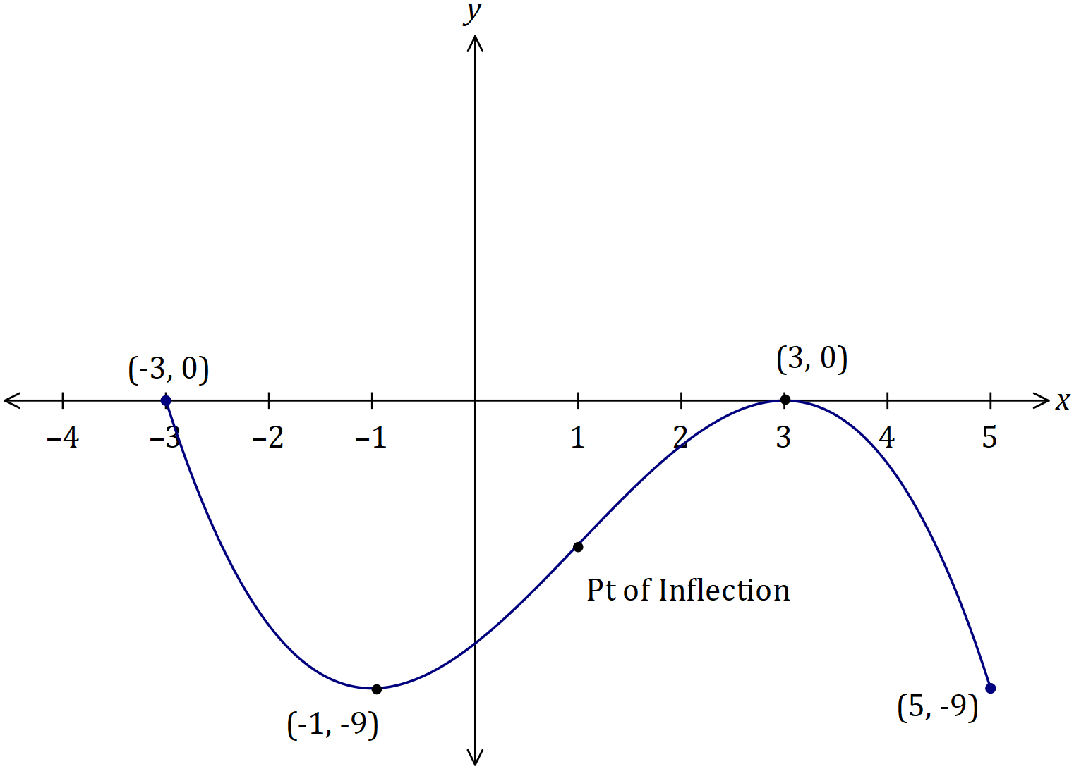

|  |
| --- |
| **Solution** |
| See graph |
| **Specific behaviours** |
| ✓ sketched over defined interval $x$ ✓ -intercepts  ✓ local minimum  ✓ labelled endpoint  ✓ approx. position pt. of inflection |

Question 21 (6 marks)

A game is played at a carnival where two fair $4$-sided dice with faces numbered $1, 2, 3$ and $4$ are tossed at the same time. Patrons pay $\$3$ for each play of the game, winning a major prize if both dice show a four or a minor prize if just one of the dice shows a four. The operator of the game buys major prizes for $\$22$ each, minor prizes for $\$2.50$ and must pay overhead costs of $\$95$ per day.

Determine how many times the game must be played per day so that the operator can expect to make a daily profit of at least $\$150$.

|  |
| --- |
| **Solution** |
| |  |  |  |  | | --- | --- | --- | --- | |  |  |  |  | |  |  |  |  | |
| **Specific behaviours** |
| ✓ defines random variable  ✓ table with row showing values RV can take  ✓ correct probabilities for all outcomes  ✓ calculates $E\left(X\right)$ ✓ forms inequality $n×E\left(X\right)≥\text{overheads+profit}$ ✓ solves inequality and writes solution |

Supplementary page

Question number: _________

Supplementary page

Question number: _________

© 2018 WA Exam Papers. Kennedy Baptist College has a non-exclusive licence to copy and communicate this document for non-commercial, educational use within the school. No other copying, communication or use is permitted without the express written permission of WA Exam Papers. SN245-125-4.